Chemistry

Unit 3

Area of Study 1 Test Answers:

Dynamic equilibrium systems

Section 1: Multiple choice 23% (16 marks)

Question 1

B The equilibrium law expression is written as a fraction with concentration of products as the numerator and concentration of reactants as the denominator.

The power to which the concentration of a reactant or product is raised is the same as the coefficient of that reactant/product in the balanced equation.

The equilibrium law does not include solids.

Question 2

C Catalysts lower the activation energy of the forward and reverse reactions but have no effect on the heat of reaction.

Question 3

B I The reaction is exothermic, so increasing the temperature will favour the reverse reaction.

II There are 3 moles of reactants and only 2 moles of products in the equation, so decreasing the volume of the container will shift the equilibrium to favour the products.

III A catalyst increases the rate of both the forward and reverse reactions equally so has no effect on the yield of product at equilibrium.

Question 4

A I Increasing the partial pressure of O2(g) means there is a greater concentration of reactant molecules and so the collision frequency of O2(g) and N2(g) will increase. Initially, there is no change in the concentration of products, so the frequency of collisions between NO(g) molecules will be unchanged.

II Decreasing the partial pressure of NO(g) will reduce the concentration of NO(g) molecules and so reduce the frequency of their collisions. Therefore, the rate of the reverse reaction will decrease. However, initially, there is no change in the concentration of O2(g) and N2(g) molecules so the rate of the forward reaction is unaltered.

III There is an equal number of moles of reactants and products so decreasing the volume of the vessel will increase the frequency of collisions between reactant molecules and between product molecules equally. Therefore, the rate of forward reaction will increase to the same degree as the rate of the reverse reaction.

Question 5

A The value of the equilibrium constant is smaller at the higher temperature. So the lower the temperature, the more product will form at equilibrium and the less H2(g) and I2(g) will be present in the equilibrium mixture. This indicates an exothermic reaction.

The value of the equilibrium constant gives no indication of reaction rate.

Question 6

B A catalyst increases the rate of the forward reaction and the reverse reaction equally.

The activation energy of both the forward and reverse reactions decrease by the same amount.

Question 7

D Lowering the pressure (increasing the volume) will cause an equilibrium shift towards the side of the equation with the greater number of moles of gases.

Only in equilibrium D will a decrease in pressure result in an equilibrium shift to the right.

Question 8

C The graph shows that the % yield of product is:

• lower at higher temperatures, so the reaction must be exothermic

• higher at higher pressures, so the number of moles on the left-hand side of the equation must be greater than on the right-hand side.

End of section 1

Section 2: Short answer 41% (28 marks)

* Indicates 1 mark

Question 9 (9 marks)

a (1 mark for correct labels; 1 mark for shape of forward reaction to point x; 1 mark for shape of reverse reaction to point x; 1 mark for shape of graph from x to y.)

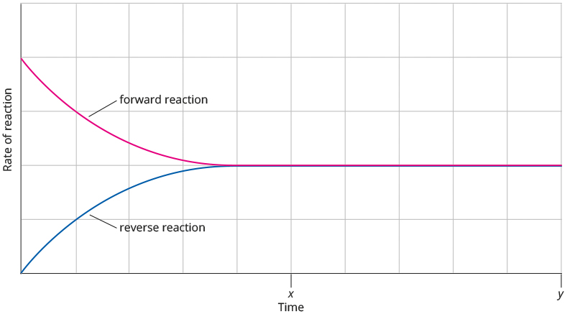

b i The equilibrium law expression for this reaction is  or

As the temperature is kept constant, at equilibrium, this fraction has a constant value.*

If the volume of the vessel is doubled, all concentrations will be halved and so the fraction becomes .*

As this can be simplified to , the equilibrium needs no adjustment to maintain the value of the equilibrium constant.*

ii When the volume of the reaction mixture increases, the reaction rates of both forward and reverse reactions decrease because the molecules are further apart and so the frequency of collisions decreases.* Because there is an equal number of molecules on each side of the equation, the decrease in reaction rate will be equal for the forward and reverse reactions and so no adjustment to the equilibrium position occurs.*

Question 10 (5 marks)

a When the bottle is opened the partial pressure of carbon dioxide gas above the surface of water in the bottle decreases* thus the rate of forward reaction decreases.* The rate of reverse reaction initially remains the same so is higher than the rate of forward reaction.* Thus the system is no longer at equilibrium.

b Increased atmospheric carbon dioxide results in more dissolved carbon dioxide.

This then pushes the equilibrium CO2(aq) + H2O(l)  H2CO3(aq) to the right, forming more carbonic acid.*

A higher concentration of carbonic acid causes the equilibrium H2CO3(aq)  H+(aq) + HCO3−(aq) to shift to the right, releasing more H+(aq) ions and therefore increasing the acidity of the water.*

Question 11 (8 marks)

a • No further colour change.

• No further change in pH.

• No further change in electrical conductivity of the solution. (Any two of the above**)

b i Addition of a small amount of OH−(aq) to neutralise some of the H+(aq) ions.*

ii The colour will be more yellow* because as the concentration of H+(aq) ions decreases the rate of reverse reaction initially has a large decrease while the forward reaction rate decreases only slightly* thus there is more yellow chromate ion relative to orange dichromate ion.*

iii The equilibrium constant will be the same at t2 as t1* because the temperature has not altered.*

Question 12 (6 marks)

a i*

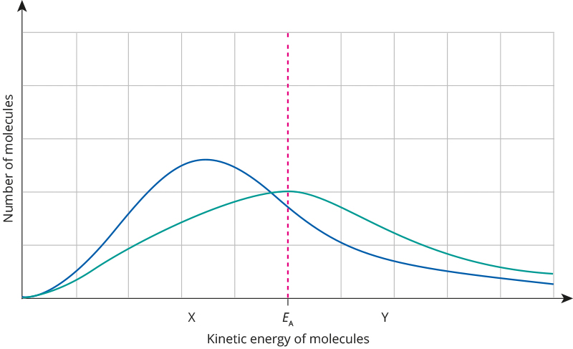

ii The area under each graph represents the number of particles with energy equal to or greater than the activation energy for the reaction. This area is much greater at the higher temperature.* Therefore, there will be a greater proportion of successful collisions at the higher temperature and so an increased reaction rate.*

b i At X* because a catalyst provides a reaction pathway with a lower activation energy.*

ii Many more particles will have energy equal to or greater than X and so the rate of reaction will be greater.*

End of section 2

Section 3: Extended answer 36% (25 marks)

Question 13 (13 marks)

a *

b The colour, initially dark brown, will become paler.*

c * For graph starting at zero and rising to a concentration of 0.15 mol L–1.

* For graph levelling to horizontal between 55 and 60 s.

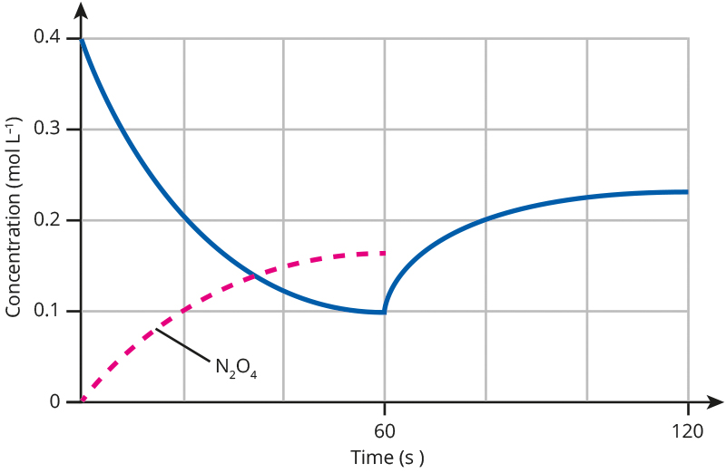

d Initially, there are only NO2 molecules present so the rate of the forward reaction is high.

As NO2 reacts to form N2O4, the concentration of NO2 decreases rapidly.*

However, as the concentration of NO2 decreases, so does the rate of the forward reaction so the concentration of NO2decreases less rapidly. At the same time, as the concentration of products builds up, the rate of the reverse reaction increases.*

Eventually, both rates become equal and equilibrium is reached whereby reactants and products are reformed as fast as they are consumed.*

Therefore, once equilibrium is reached there is no net change in reactant or product concentrations.*

e At the 60-second mark, the concentration of NO2 increases as the temperature increases. An endothermic reaction is favoured by an increase in temperature* (because an increase in temperature increases the rate of an endothermic reaction more than that of an exothermic one).

So the formation of NO2 must be endothermic while the formation of N2O4 must be exothermic.*

f

|  |  |
| --- | --- |
| Observation | Explanation |
| As soon as the plunger of the syringe is pushed inwards, the colour of the contents of the syringe becomes significantly darker brown. | At the instant the plunger is pushed inwards, the concentration of all gases increases, including that of the brown NO2, so the mixture appears darker brown.* |
| After a few minutes, the colour of contents of the syringe have become paler, but not as pale as before the plunger was pushed inwards. | The reduction in volume leads to an increase in concentration of both NO2(g) and N2O4(g)* so the rate of both the forward and reverse reactions increase* but the forward reaction rate increases more thus reducing the concentration of NO2(g)* but not lower than what it was before the plunger was pushed in. (The forward rate increases more because there are more particles of NO2(g) than N2O4(g) and so is more affected by the decrease in volume.) |

Question 14 (12 marks)

a The partial pressure of oxygen in the alveoli will need to be high.*

The partial pressure of carbon dioxide in the alveoli will need to be low.*

When the partial pressure of oxygen is high the rate of the forward reaction will be high relative to the rate of reverse reaction thus leading to oxygen dissolving in the plasma.*

When the partial pressure of carbon dioxide is low the rate of the forward reaction will be low relative to the rate of reverse reaction thus leading to carbon dioxide leaving the plasma.*

b

|  |  |
| --- | --- |
| Species | When concentration highest (write ‘just leaving lungs’ or ‘just leaving body cell’) |
| HbO2(aq) | just leaving lungs* |
| HbCO2–(aq) | just leaving body cell* |
| HCO3–(aq) | just leaving body cell* |
| H+Hb(aq) | just leaving body cell* |

c There will be a low concentration of O2(aq) as well as the high concentrations of CO2(aq) and HbO2(aq) so in equilibrium 1 the rate of forward reaction will be higher than the rate of reverse reaction* thus releasing O2 from the Hb.*

The high concentration CO2(aq) will also mean that the rates of the forward reactions will be higher than the rates of reverse reactions in equilibrium 2 so giving an increased concentration of H+(aq).* The increased concentration of H+(aq) (from equilibria 1 and 2) will increase the rate of forward reaction over the reverse reaction in equilibrium 3, again releasing O2.*

End of answers